|  |  |  |
| --- | --- | --- |
| **Final-IMS-logo-14thMay.jpg** |  |  |

Session: 2023-24 Semester: 5th

Course Code: BCA 503 Course Name: Computer Network

ASSINGMENT 3

**1**. Define Point to point protocols. Discuss its transmission states by

depicting a diagram.

2. What do you mean by term Multiplexing?

Compare types of multiplexing.

3. What do you mean by error and its types? Explain checksum error detection method with example.

4. A bit stream 1101011011 is transmitted using the standard CRC method. The generator polynomial is x4+x+1. What is the actual bit string transmitted.

5. Find the shorstest path to all nodes from source node **b** using **DIJKSTRA’s Algorithm**

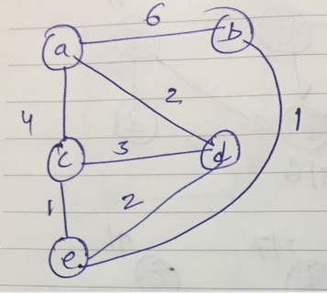

**Note : Use A4 Sheets for doing assignment. Submission Date is 19 Oct’23.**

Ms. Shilpi Singhal